Santam Sengupta
Marketing Consultant
B 183 Ground Floor
Sector 14
Noida 201301
Uttar Pradesh
Telephone No. +91 9971153231 Email : santamsengupta@gmail.com
Invoice No. Comm/24-25 |  |  |  | Date: |  |  |  | 1st July 2025
 |  | M/s. Prologic First India Pvt. Ltd.
 |  | # 578, 2nd Floor, Udyog Vihar Phase 5, Gurgaon
We are pleased to present our Invoice for Professional Services as detailed below:-

Rupees sixty five thousand, four hundred & seventy one only.
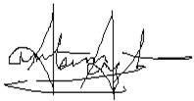
Santam Sengupta

